Realtor Web Craft
https://testlinkdev.com/custom/realtor-web-craft/index.php
Meta title: realtor web craft, realestate website development company​
Meta description: realtor web craft, realestate website development company​
Word count Accounting to UI:
Also Kindly add FAQ’s Section on every single page.
Web content: realtor web craft, realestate website development company​, best real estate websites

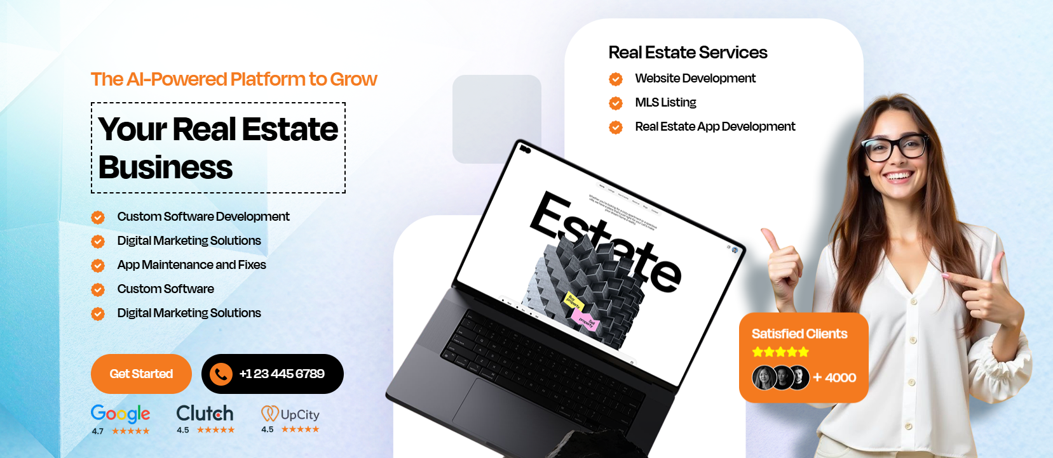

Meta Title:
Realtor Web Craft | Real Estate Website Development Company

Meta Description:
Realtor Web Craft is a leading real estate website development company offering custom designs, SEO, and digital solutions for real estate professionals.

Realtor Web Craft Pro in Creating the

Best Real Estate Websites
- Custom Software Development
- Digital Marketing Solutions
- MLS Listing Integration
- Real Estate App Development
- App Maintenance and Fixes

What You Get
Stunning design
User-friendly navigation
Powerful backend features.

CTA
Get Started Today!
Click to Call
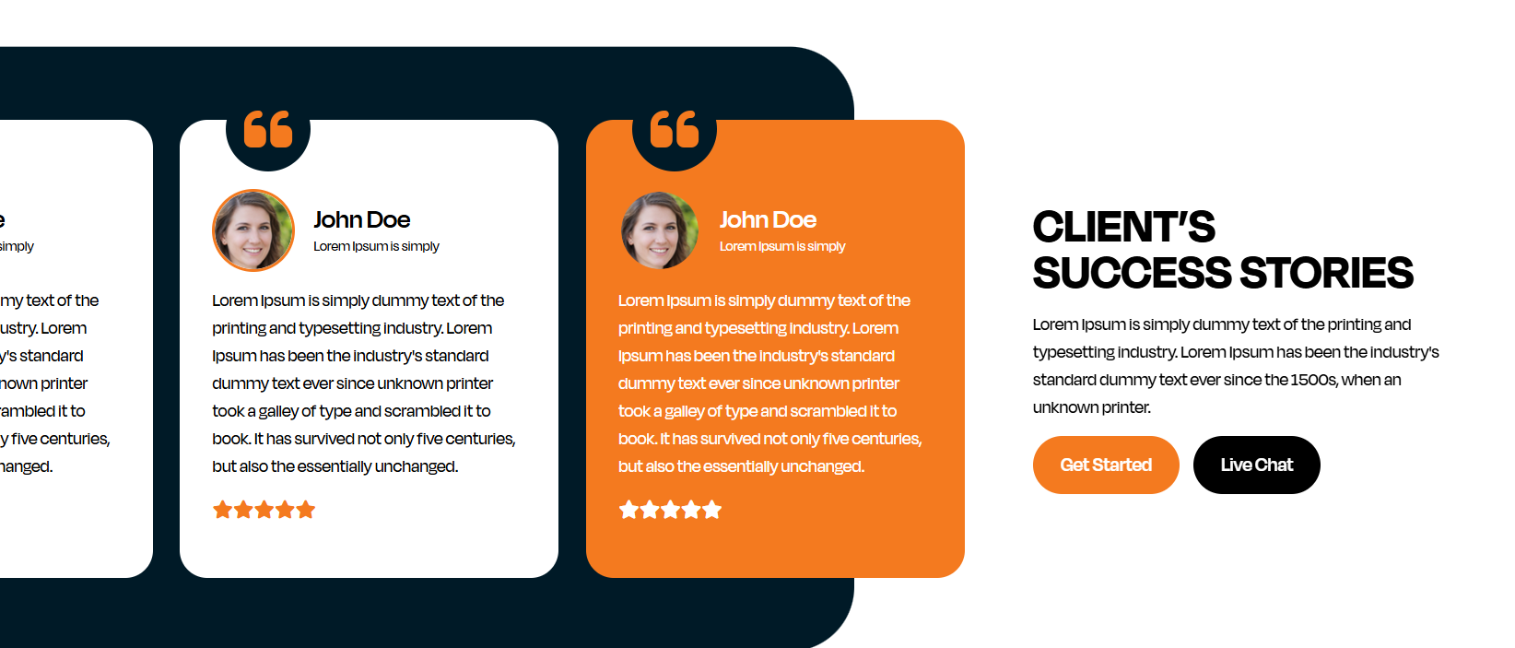

CLIENT’S SUCCESS STORIES
Realtor Web Craft has helped countless real estate professionals grow their businesses with the best real estate websites.
Jane Smith
"Working with Realtor Web Craft was a game-changer for my real estate business. Their team built me a beautiful website that’s easy to manage and has helped me connect with more clients. I highly recommend them for anyone looking for the best real estate websites!"
Jonathan Alexis Soli
"I’ve worked with several real estate website development companies before, but Realtor Web Craft really stands out. Their expertise in creating high-converting real estate websites made all the difference. My business has grown significantly since the launch!"
Sarah Johnson
"As a busy real estate agent, I needed a website that worked smoothly and looked professional. Realtor Web Craft delivered exactly that. I now have a site that showcases my properties and helps me capture leads efficiently."
David Miller
"Realtor Web Craft transformed my online presence. My website is now faster, more user-friendly, and generates more leads than before. If you’re looking to take your real estate business online, this real estate website development company is the one to trust!"
Emily Davis
"My website was outdated and hard to navigate, but after partnering with Realtor Web Craft, my new site is modern, sleek, and easy to manage. They truly build the best real estate websites, and I’ve seen my business flourish as a result."
Michael Green
"Thanks to Realtor Web Craft, I now have a professional website that integrates seamlessly with MLS listings. It’s easy for clients to find properties, and for me to manage everything. I’m so glad I chose them for my real estate website development!"
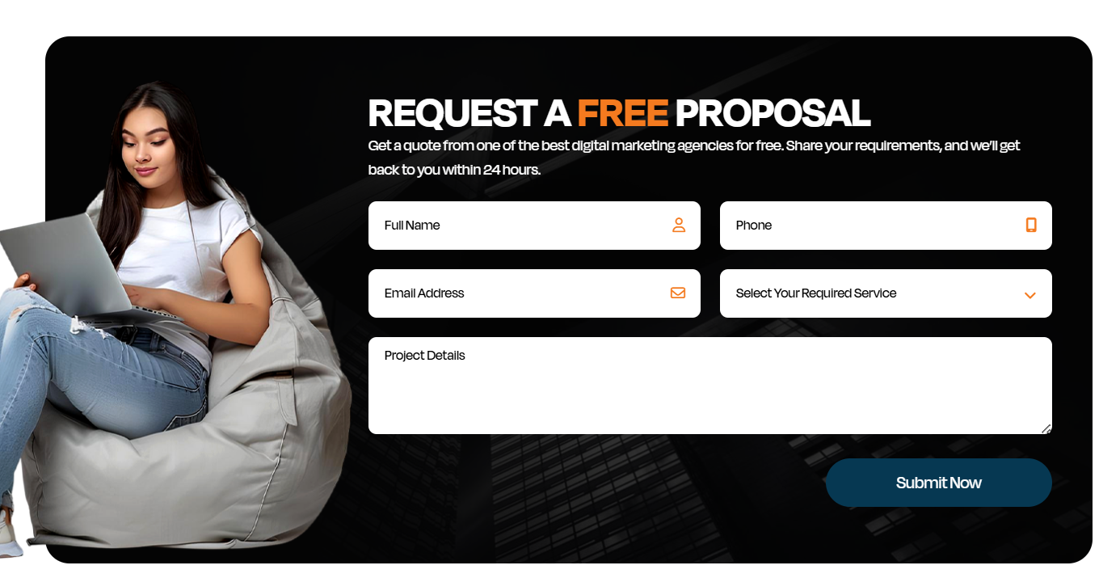

Get Started Today!
Start your journey towards a better digital presence today with Realtor Web Craft. Our AI-powered platform is the future of real estate websites.
Call now at +1 23 445 6789 or click "Get Started" to schedule a free consultation.
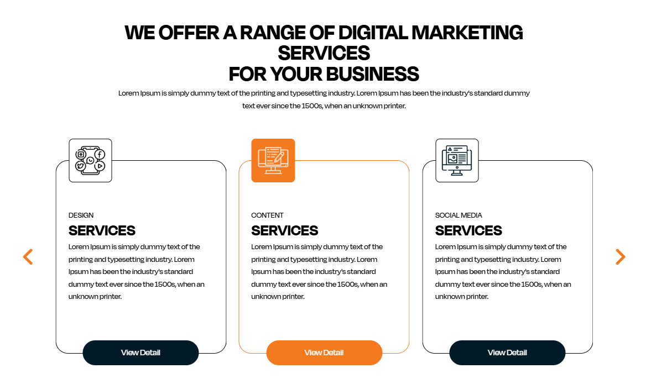

WE OFFER A RANGE OF DIGITAL SOLUTIONS

FOR YOUR REAL ESTATE BUSINESS
At Realtor Web Craft, we provide powerful digital services that help real estate professionals grow online, get more leads, and run their business smoothly.

WEB & APP DEVELOPMENT
We build professional real estate websites and mobile apps that make property browsing simple for your clients.
From search filters to MLS integration, our developers design with growth in mind.
Perfect for: Realtors, brokers, property managers, agencies
- Best real estate websites made just for your business
- User-friendly and responsive on all devices
- Lead capture built into every site
View Detail

CUSTOM SOFTWARE SOLUTIONS
Get custom real estate software created to solve your business challenges.
Whether you need CRM tools, client portals, or internal dashboards, our team builds it for you.
- Tailored to your workflow
- Scalable as your business grows
- Built by expert developers
View Detail

DIGITAL MARKETING & LEAD GENERATION
Grow your online presence with smart marketing solutions designed for real estate.
We help you reach potential buyers and sellers through SEO, ads, social media, and email strategies.
- SEO optimized for real estate searches
- Paid ads that bring clients
- Content and social campaigns that build authority
View Detail

BACKEND & DEVOPS SUPPORT
Our tech team provides reliable infrastructure, maintenance, and backend support for your digital platforms.
We keep your systems secure, fast, and always up-to-date.
- Secure servers and backups
- Performance monitoring
- Fast issue resolution
View Detail

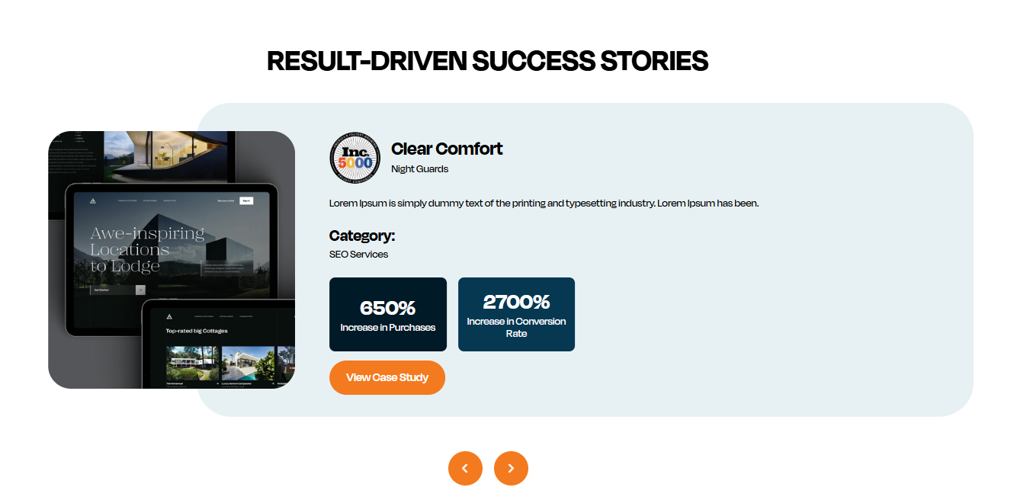

Result-Driven Success Stories

Luxury Living Real Estate
Category: Web Development
Increase in Engagement: 500%
New Leads Generated: 1200+
We helped a luxury real estate agency redesign their website to create an immersive experience for potential buyers. By focusing on high-quality visuals and seamless property browsing, we boosted their site engagement and increased new client leads by over 500%. The enhanced mobile experience and optimized property search were key to success.
View Case Study

Green Estates Realty
Category: Digital Marketing
Increase in Website Traffic: 750%
Leads Generated: 3000+
Green Estates turned to us for a comprehensive digital marketing strategy. Through targeted SEO, content marketing, and PPC campaigns, we increased organic traffic by 750% and generated over 3000 leads in just 3 months. The increased visibility on search engines made a huge difference in the company’s performance.
View Case Study

Skyline Property Group
Category: Software Solutions
Improvement in Operational Efficiency: 40%
Revenue Increase: 25%
Skyline Property Group needed a custom CRM to manage their increasing number of properties and clients. We developed a tailored software solution that streamlined their internal processes, improved data management, and reduced response times. This led to a 40% improvement in operational efficiency and a 25% increase in overall revenue.
View Case Study
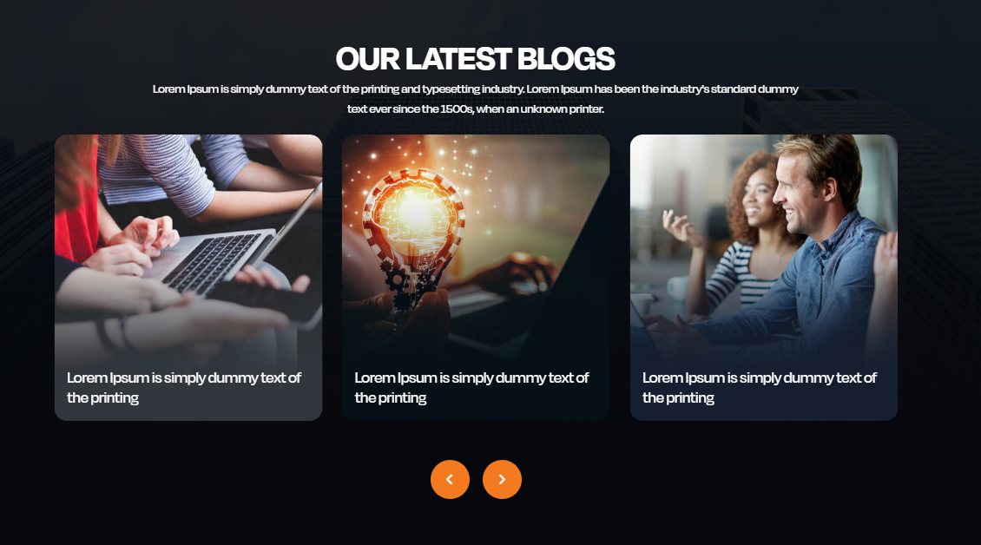

OUR LATEST BLOGS
Check out our latest blog posts to stay updated with the best tips, trends, and strategies in the real estate industry. From cutting-edge digital solutions to essential marketing strategies, we’ve got you covered.

Blog 1: Boost Your Real Estate Business with SEO Best Practices
Excerpt:
Discover how to increase your real estate website's visibility on search engines. This blog post provides a comprehensive guide on using SEO techniques tailored to the real estate industry. Learn about keyword research, content optimization, and technical SEO strategies that help drive organic traffic and increase leads.

Blog 2: The Importance of Custom Websites for Real Estate Professionals
Excerpt:
In the highly competitive real estate market, having a website tailored to your needs is essential. This blog highlights the importance of custom website design for real estate businesses. We dive into features like IDX/MLS integration, responsive design, and user-friendly interfaces that boost lead generation.

Blog 3: How Social Media is Transforming the Real Estate Industry
Excerpt:
Social media isn’t just for influencers; it’s a powerful tool for real estate professionals to engage with clients, showcase properties, and grow their business. Explore how to leverage platforms like Instagram, Facebook, and LinkedIn to reach potential buyers and sellers effectively.

Read More Content-Inner Page Blogs

Blog 1: Boost Your Real Estate Business with SEO Best Practices
Introduction:
In the digital age, having a strong online presence is crucial for real estate professionals. But simply having a website isn’t enough. To truly stand out, you need a website that ranks well on search engines. SEO (Search Engine Optimization) is the key to making that happen. In this blog, we’ll explore SEO best practices specifically designed for real estate businesses, helping you boost your visibility and generate more leads.
1. Keyword Research:
The first step in any SEO strategy is identifying the right keywords. For real estate, keywords like "buy homes in [your city]" or "real estate agents near me" are highly relevant. Tools like Google Keyword Planner and SEMrush can help you discover keywords that your target audience is searching for. Make sure to include long-tail keywords (phrases with 3-4 words) as they tend to be more specific and have less competition.
2. On-Page SEO:
On-page SEO refers to optimizing elements on your website itself. This includes:
- Optimizing page titles and meta descriptions: These should include your target keywords and be enticing enough for users to click on your page.
- Content optimization: Create informative, engaging, and keyword-rich content that answers your audience’s questions.
- Header tags (H1, H2, H3, etc.): Proper use of header tags helps organize content and signals to search engines what the content is about.
3. Local SEO:
For real estate agents, local SEO is particularly important. Optimize your website for local searches by adding location-specific keywords (e.g., “homes for sale in [city name]”). Create a Google My Business profile and encourage clients to leave reviews. This helps boost your visibility in Google Maps and local search results.
4. Mobile-Friendly Website:
With more people using smartphones to search for homes, ensuring your website is mobile-friendly is critical. Google also ranks mobile-friendly websites higher in search results, so make sure your site is responsive and loads quickly on all devices.
5. Link Building:
Link building is the process of acquiring backlinks from other reputable websites. The more high-quality links pointing to your website, the higher your site will rank on search engines. Reach out to local businesses, bloggers, and real estate influencers to get featured on their sites and gain backlinks.
Conclusion:
SEO may seem like a complex task, but it’s essential for real estate businesses that want to succeed online. By focusing on keyword research, on-page SEO, local SEO, mobile optimization, and link building, you can improve your website’s visibility and attract more leads. Start implementing these SEO best practices today, and watch your online presence grow!

Blog 2: The Importance of Custom Websites for Real Estate Professionals
Introduction:
In today’s digital world, a generic website just won’t cut it, especially in the competitive real estate market. Your website is often the first impression potential clients have of your business. Having a custom website can make all the difference in attracting, engaging, and converting leads. In this blog, we’ll discuss why a custom website is essential for real estate professionals and the features it should include.
1. Personalized Design and Branding:
A custom website allows you to design your site around your brand and your audience. Unlike template-based sites, which can look generic, a custom website reflects your business’s unique identity. From colors and logos to fonts and imagery, every detail can be tailored to match your brand’s voice and values. A well-designed site creates a memorable experience that leaves a positive impression on visitors.
2. IDX/MLS Integration:
For real estate websites, one of the most important features is the integration of IDX (Internet Data Exchange) or MLS (Multiple Listing Service) listings. This allows visitors to search for properties directly on your site, giving them a seamless experience. Custom websites can be integrated with IDX/MLS systems, ensuring that your clients always have access to up-to-date listings and property information.
3. Mobile Optimization:
With more people using smartphones to search for homes, having a mobile-friendly website is crucial. Custom websites can be designed to be fully responsive, ensuring they look great and work well on all devices. This is especially important in real estate, where clients may want to browse listings or contact you while on the go.
4. Faster Load Times:
A custom-built website can be optimized for faster load times. Slow-loading websites are a major turn-off for users and can result in high bounce rates. A custom site ensures that your website’s performance is optimized, offering a better user experience and improving your site’s SEO ranking.
5. Scalability and Future Growth:
As your real estate business grows, your website needs to grow with it. Custom websites are scalable, meaning they can be easily updated and expanded as your business evolves. Whether you want to add new features, improve functionality, or update your design, a custom site offers the flexibility to meet your changing needs.
Conclusion:
A custom website offers a range of benefits for real estate professionals, from personalized branding and seamless IDX integration to mobile optimization and faster load times. If you’re serious about attracting and converting leads, investing in a custom website is a smart decision that will set you apart from the competition.

Blog 3: How Social Media is Transforming the Real Estate Industry
Introduction:
Social media has changed the way businesses interact with customers, and the real estate industry is no exception. From showcasing properties to building a personal brand, social media platforms like Facebook, Instagram, and LinkedIn have become essential tools for real estate professionals. In this blog, we’ll explore how social media is transforming the real estate industry and how you can use it to grow your business.
1. Property Showcasing and Virtual Tours:
Social media platforms are the perfect place to showcase your properties. High-quality photos and videos of homes can grab the attention of potential buyers and generate interest. Platforms like Instagram and Facebook allow real estate agents to post property images and videos directly to their followers. Additionally, virtual tours and live streaming on Facebook and Instagram make it easier for clients to view properties remotely, which has become especially important during the pandemic.
2. Building Your Personal Brand:
Social media allows you to build your personal brand as a real estate professional. By sharing valuable content, insights, and tips about the real estate market, you position yourself as an expert in your field. Personal branding helps create trust with potential clients and makes it easier for them to connect with you on a deeper level.
3. Targeted Advertising:
Social media platforms offer powerful advertising tools that allow you to target specific demographics. Whether you’re targeting first-time homebuyers, investors, or people looking to downsize, social media ads can help you reach the right audience. These ads can be optimized for real estate services, ensuring your budget is spent on reaching potential leads.
4. Engagement and Networking:
Social media isn’t just for advertising, it’s also a great way to engage with your audience. Responding to comments, liking and sharing posts, and participating in local groups or discussions can help you connect with potential clients. Networking on platforms like LinkedIn can also open doors to business partnerships and referral opportunities.
5. Local Marketing:
Social media allows you to market your real estate services to local audiences. By using location-based hashtags and geo-targeting features on platforms like Instagram, Twitter, and Facebook, you can attract clients who are actively searching for properties in your area.
Conclusion:
Social media has revolutionized the way real estate professionals connect with clients and market properties. Whether you’re showcasing properties, building your personal brand, or targeting specific buyers, social media is an essential tool for success in today’s real estate market. Start incorporating social media into your marketing strategy and watch your business grow!

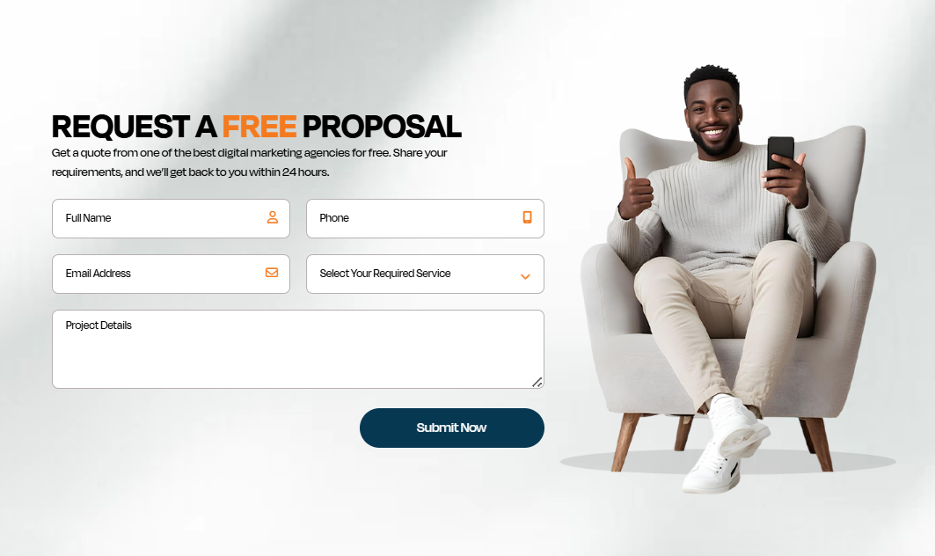

FAQs

1. What services does Realtor Web Craft provide?
At Realtor Web Craft, we build custom real estate websites, develop mobile apps, and provide software solutions tailored for real estate professionals. We also offer digital marketing services, backend support, and DevOps assistance to help your business grow online.

2. Why do I need a custom real estate website?
A custom website helps your business stand out. It engages visitors, showcases property listings, captures leads, and improves your online visibility. Unlike generic templates, custom sites are designed just for your audience and goals, giving you the best real estate websites for your brand.

3. How long does it take to build a real estate website?
The timeline depends on your needs. A basic site can take a few weeks, while a full real estate web development project with advanced features (like MLS/IDX integration or custom software) may take longer. We’ll give you a clear timeline after discussing your requirements.

4. Do you offer digital marketing along with web development?
Yes! In addition to building your site, we provide digital marketing solutions to help generate traffic and leads. This includes SEO, social media promotions, content strategy, and paid advertising so your real estate business gets more visibility online.

5. How do I get started with Realtor Web Craft?
Just contact us through our website or phone. We’ll discuss your goals, review your business needs, and propose a solution that fits your budget and timeline. Our team will guide you through every step, from design to launch and ongoing support.



Stay Connected
Follow us for updates, tips, and insights on how digital solutions can elevate your real estate business.

https://testlinkdev.com/custom/realtor-web-craft/web-development.php
Meta title: Real Estate Website Design, Custom Real Estate Website Design
Meta description: Real Estate Website Design, Custom Real Estate Website Design
Word count Accounting to UI:
Also Kindly add FAQ’s Section on every single page.
Web content: Real Estate Website Design, Custom Real Estate Website Design
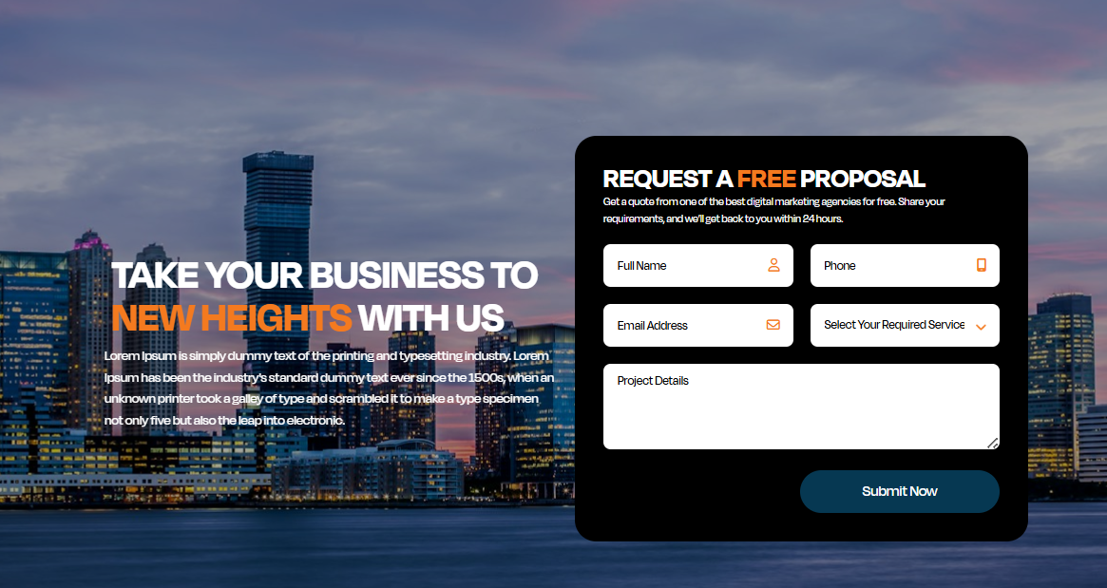

Meta Title:
Custom Real Estate Website Design | Best In Your Area

Meta Description:
Get professional Real Estate Website Design and Custom Real Estate Website Design tailored for your business. Boost leads, conversions, and online visibility today!

TAKE YOUR BUSINESS TO NEW HEIGHTS WITH US
We are pro max in Real Estate Website Design that helps your business stand out online. With our Custom Real Estate Website Design services, we create visually stunning, user-friendly, responsive, and optimized websites to capture leads.

REQUEST A FREE PROPOSAL
Get a quote from one of the best digital marketing agencies for free. Share your requirements, and we’ll get back to you within 24 hours.

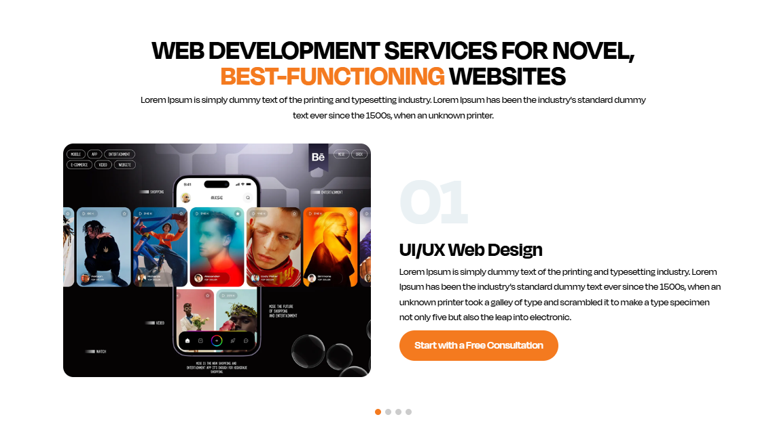

Innovative Web Development Services for High-Performing Real Estate Websites
Let us help you create a custom, high-functioning website that elevates your real estate business to new heights with tailored designs, seamless functionality, and optimized performance

01. Custom Web Development
We build fully tailored websites designed for your real estate business, not generic templates. From clean code to advanced backend support, we develop sites that scale, load fast, and deliver results. Your site will match your branding and business goals perfectly, with room to grow.

02. Responsive & Mobile-Optimized Design
More than 60% of users browse on phones and tablets, so every site we make works flawlessly on all screens. A responsive design improves user experience, increases engagement, and boosts search engine visibility so your visitors stay longer and convert more.

03. Advanced Search & MLS/IDX Integration
Make property browsing simple with powerful search filters and real-time listing updates. Users can filter by price, location, beds, features, and more, all integrated directly with MLS/IDX feeds to ensure up-to-date listings and better engagement.

04. Secure Backend & Performance Optimization
We ensure strong security, fast loading speeds, and highly reliable servers to protect your data and give visitors a seamless experience. Features include encryption, performance tuning, and ongoing back-end support so your real estate website stays secure and high-performing.
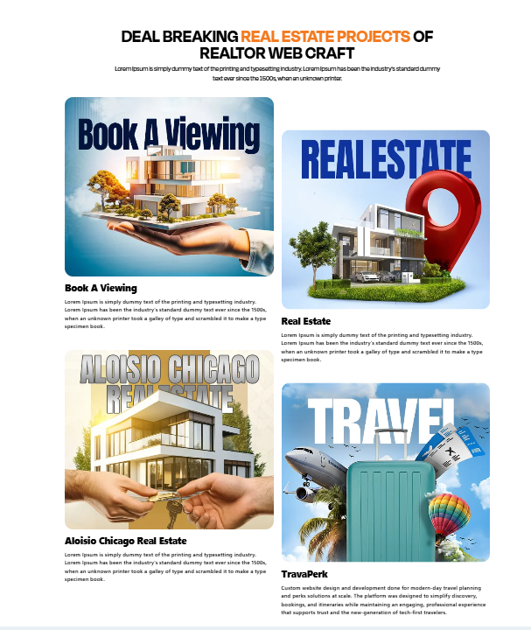

DEAL-BREAKING REAL ESTATE PROJECTS OF REALTOR WEB CRAFT
Explore our latest custom-designed websites that take real estate to new heights. Our Real Estate Website Design solutions are built for functionality, user engagement, and converting leads effectively. Each project reflects our expertise in Custom Real Estate Website Design, tailored to meet the unique needs of real estate businesses.

Book A Viewing
Offer your clients an easy way to book viewings directly from your website. Our Custom Real Estate Website Design ensures a seamless, user-friendly experience, allowing potential buyers to schedule property viewings at their convenience.

Green Grass Real Estate
Transform your online presence with a beautifully designed real estate website. From detailed property listings to easy navigation, we create engaging sites that reflect the professionalism and expertise of your business.

Aloisio Chicago Real Estate
A tailor-made website designed for Aloisio Chicago, focusing on high-end properties. Our Real Estate Website Design services ensure a seamless browsing experience that highlights your listings, captures leads, and builds trust with prospective clients.

TravaPerk
We also specialize in creating websites for real estate travel solutions. TravaPerk showcases our Custom Real Estate Website Design expertise, with a focus on modern design, ease of booking, and a smooth travel experience for clients.

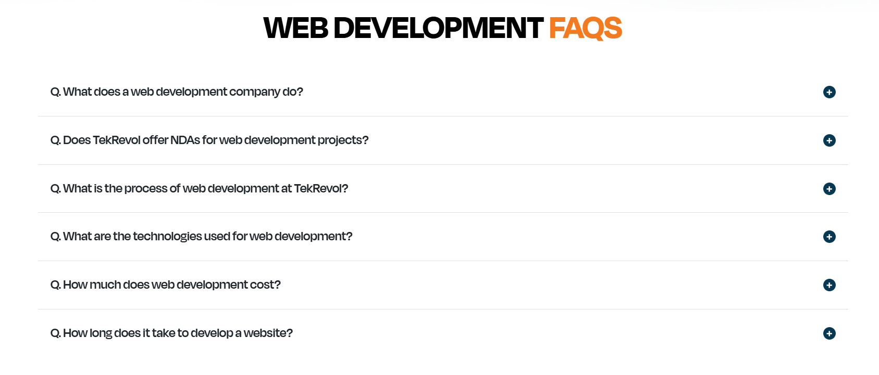

FAQS
Q1: What does a real estate website development company do?
A real estate website development company specializes in designing and building websites specifically for real estate businesses. They create custom real estate websites that include features such as MLS/IDX integration, lead generation forms, property search functionality, and mobile optimization, helping real estate professionals attract and convert potential clients.

Q2: Do you offer NDAs for web development projects?
Yes, we understand the importance of confidentiality. We offer NDAs (Non-Disclosure Agreements) for all web development projects to ensure that your business ideas, proprietary data, and client information remain protected throughout the development process.

Q3: What is the process of developing a custom real estate website?
Our web development process includes several key steps:
- Consultation: We discuss your requirements, target audience, and desired features.
- Design: Our team creates a custom UI/UX design tailored to your brand and user experience needs.
- Development: We implement features like property listings, IDX integration, and lead capture tools.
- Testing & Launch: We thoroughly test the website for functionality, security, and performance before going live.
- Ongoing Support: After launch, we provide continuous support and maintenance to ensure your site runs smoothly.

Q4: What are the technologies used for real estate website development?
We use a combination of modern web technologies to build high-performing websites, including:
- HTML5, CSS3, JavaScript for responsive and interactive designs
- ReactJS, AngularJS for dynamic user interfaces
- WordPress, Drupal for content management
- PHP, MySQL for backend server-side development
- IDX/MLS APIs for property listing integration
- Google Analytics & SEO tools for tracking and optimizing site performance

Q5: How much does it cost to develop a real estate website?
The cost of developing a custom real estate website varies based on factors like the complexity of the design, features (e.g., MLS integration, advanced search filters), and the number of pages required. Generally, a basic website can start from a few thousand dollars, while more complex projects can cost significantly more. Reach out to us for a personalized quote based on your specific needs.

https://testlinkdev.com/custom/realtor-web-craft/web-development.php ( same homepage link)
Meta title: real state app development company​, android app development company​
Meta description: real state app development company​, android app development company​
Word count Accounting to UI:
Also Kindly add FAQ’s Section on every single page.
Web content: real state app development company​, android app development company​

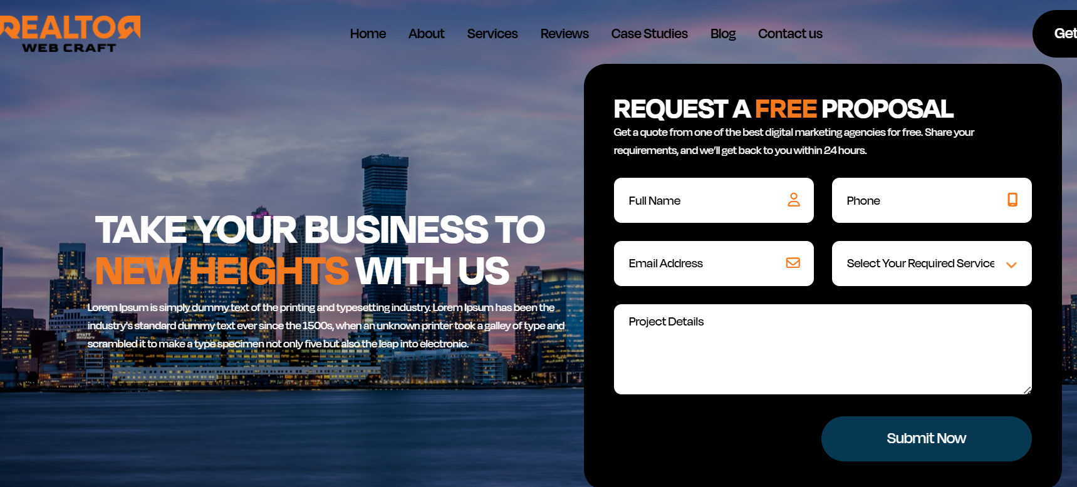

Meta Title:
Real Estate Android App Development | Realtor Web Craft

Meta Description:
We are a leading Real Estate Android App Development Company for real estate businesses. Tailored solutions to improve client and property management.

Real Estate Focused Android App Development Company
We create real estate and Android Apps to help businesses transform their digital presence. Whether you're a real estate agent, a broker, or a property manager, our real estate app development company creates custom mobile applications designed to simplify property searches, enhance customer interactions, and boost sales.
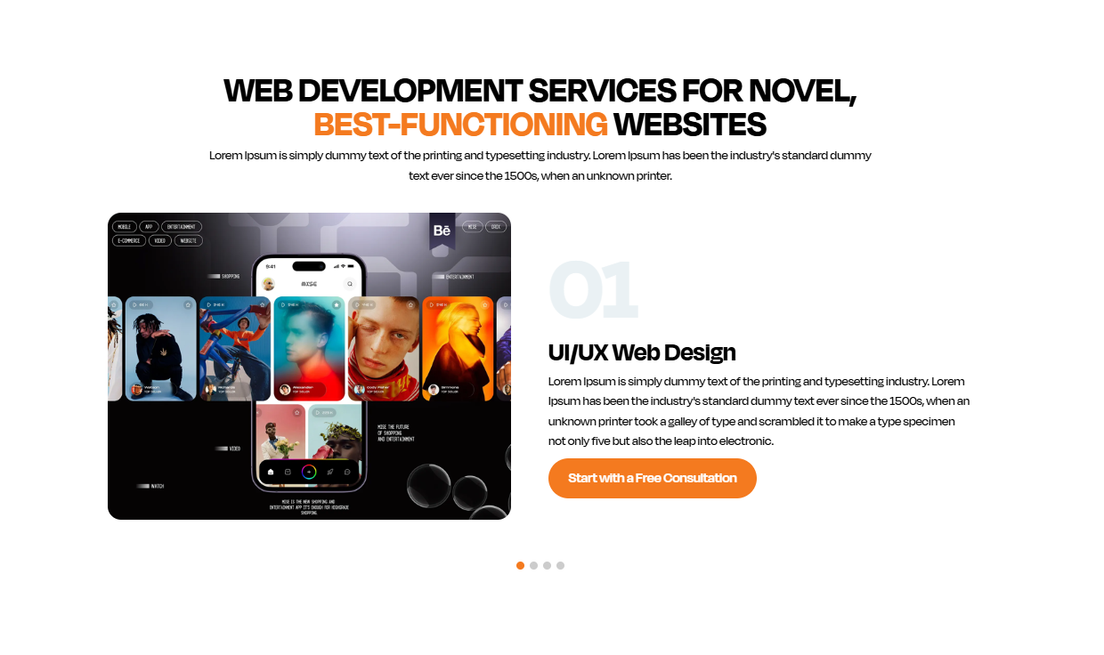
Advanced Android App Development for Real Estate Growth
Grow your business with custom Android app development that engages clients, simplifies property browsing, and turns visitors into loyal customers. As a trusted real estate app development company, we build apps that deliver performance, reliability, and real value.

Intuitive UI/UX Design
User-Friendly Real Estate App Interfaces
Our Android apps are designed with clear, modern, and easy-to-navigate screens. With smart layouts, optimized buttons, and intuitive controls, your users will enjoy browsing listings, saving favorites, and contacting you, all through a smooth mobile experience.
Why it Matters: Great design boosts engagement and increases the time users spend in your app.

MLS/IDX Integration & Smart Search
Powered Property Search Tools
We integrate MLS/IDX systems within your Android app so users can see up-to-date listings, filter properties, and search by location, price, or features. Your clients get powerful search with real data, right on their phones.
Why it Matters: Faster, smarter property search increases inquiries and improves client satisfaction.

Push Alerts & Client Engagement Features
Stay Connected with Your Users
With built-in push notifications, saved search alerts, and automated updates, your app keeps customers informed about new listings and open houses. We also include in-app messaging tools so buyers can connect with you instantly.
Why it Matters: Active engagement means higher retention and more direct leads.

Secure & Scalable Backend Support
Fast Performance & Safe Data Handling
We build Android apps with secure servers, reliable databases, and optimized performance so your app runs fast even with heavy data loads. From client profiles to saved searches and message history, everything stays safe, fast, and ready to grow as your business expands.
Why it Matters: Security and speed build trust and ensure your app adapts to future needs.

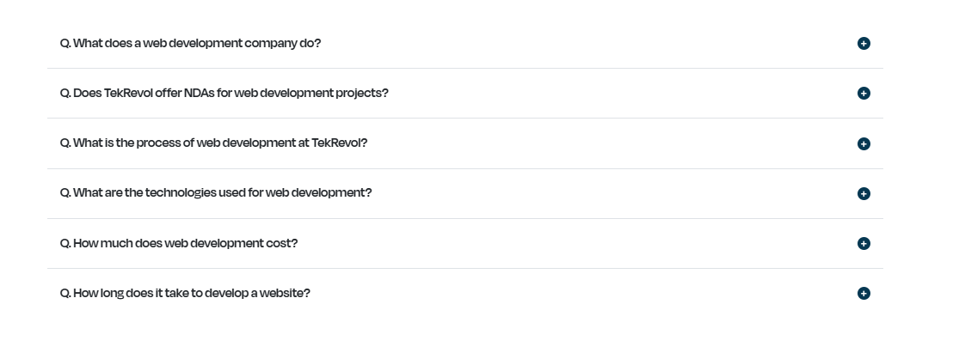

FAQs

Q1: What services do you offer for real estate app development?
We offer custom real estate app development for Android platforms. Our apps include features like property listings, virtual tours, user authentication, lead management, and more to help you connect with clients effectively.

Q2: Why should I choose an Android app for my real estate business?
Android apps are widely used and offer great flexibility. With over 2.5 billion active Android users globally, it’s an ideal platform to reach a larger audience and engage clients effectively through features like real-time property updates and easy communication channels.

Q3: How long does it take to develop a real estate Android app?
The timeline for Android app development varies depending on the complexity and features of your app. Generally, it takes 6–12 weeks to develop a real estate app, including design, development, testing, and deployment.

Q4: How much does it cost to build an Android app for my real estate business?
The cost of developing a real estate Android app depends on factors like features, design, and complexity. We offer custom quotes based on your business needs, ensuring you get the most value for your investment.

Q5: Can you integrate the real estate app with my website and MLS system?
Yes, our real estate app development company can integrate your Android app with your existing website, MLS, CRM, and other platforms to provide seamless synchronization and improve overall user experience.
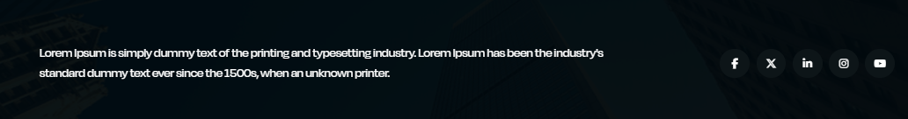

Get Started with a Custom Android App Today
Talk to our team at Realtor Web Craft your dedicated real estate app development company, and let’s build an Android app that grows your reach, drives leads, and elevates your digital real estate presence.

https://testlinkdev.com/custom/realtor-web-craft/web-development.php
Meta title: Best Real Estate Agent Websites, top rated real estate agent websites​
Meta description: Best Real Estate Agent Websites, top rated real estate agent websites
Word count Accounting to UI:
Also Kindly add FAQ’s Section on every single page.
Web content: Best Real Estate Agent Websites, top rated real estate agent websites

Meta Title:
Top Rated Real Estate Agent Websites By Realtor Web Craft

Meta Description:
Discover the Best Real Estate Agent Websites and Top Rated Real Estate Agent Websites designed to boost engagement, lead generation, and business growth.

Top Rated Real Estate Agent Web Development Company
We create Best Real Estate Agent Websites to help businesses transform their digital presence. Whether you're a real estate agent, a broker, or a property manager, our top-rated real estate agent websites are designed to simplify property searches, enhance customer interactions, and boost sales.

Advanced Web Development for Real Estate Growth
Grow your business with custom real estate website design that engages clients, simplifies property browsing, and converts visitors into loyal customers. As a trusted provider of Best Real Estate Agent Websites, we build sites that deliver performance, reliability, and real value.

User-Friendly Real Estate Website Interfaces
Our real estate websites are designed with clear, modern, and easy-to-navigate screens. With smart layouts, optimized buttons, and intuitive controls, your users will enjoy browsing listings, saving favorites, and contacting you, all through a smooth web experience.
Why it Matters: Great design boosts engagement and increases the time users spend on your top-rated real estate agent website, leading to more conversions.

Powered Property Search Tools
We integrate MLS/IDX systems within your real estate website so users can view up-to-date listings, filter properties, and search by location, price, or features. Your clients get powerful search with real data, right at their fingertips.
Why it Matters: Faster, smarter property searches increase inquiries and improve client satisfaction on your top-rated real estate agent website.

Stay Connected with Your Users
With built-in push notifications, saved search alerts, and automated updates, your real estate website keeps customers informed about new listings and open houses. We also include in-app messaging tools so buyers can connect with you instantly.
Why it Matters: Active engagement means higher retention and more direct leads for your Best Real Estate Agent Website.

Fast Performance & Safe Data Handling
We build real estate websites with secure servers, reliable databases, and optimized performance to ensure fast loading times, even with heavy data loads. From client profiles to saved searches and message history, everything stays safe, fast, and ready to grow as your business expands.
Why it Matters: Security and speed build trust and ensure your Best Real Estate Agent Website adapts to future needs.

FAQs
Q1: What services do you offer for real estate app development?
We specialize in custom real estate app development for Android platforms. Our apps come with essential features such as property listings, virtual tours, user authentication, lead management, and more to help you create top-rated real estate agent websites that connect you with clients and grow your business.

Q2: Why should I choose an Android app for my real estate business?
Android apps are widely used and offer excellent flexibility. With over 2.5 billion active Android users globally, they’re an ideal platform for reaching a larger audience. Through real-time property updates and easy communication features, an Android app helps improve client engagement, making it a valuable tool for your Best Real Estate Agent Website.

Q3: How long does it take to develop a real estate Android app?
The development timeline for an Android real estate app varies depending on the complexity and features. On average, it takes 6–12 weeks to complete, including design, development, testing, and deployment, ensuring your top-rated real estate agent website is ready for your clients.

Q4: How much does it cost to build an Android app for my real estate business?
The cost to develop a real estate Android app depends on features, design, and app complexity. We provide custom quotes tailored to your business needs, ensuring your investment in a Best Real Estate Agent Website offers maximum value and effectiveness.

Q5: Can you integrate the real estate app with my website and MLS system?
Yes, as a trusted real estate app development company, we can seamlessly integrate your Android app with your existing website, MLS, CRM, and other platforms. This synchronization enhances the overall user experience and makes your top-rated real estate agent website more efficient and dynamic.

Start Your Journey with a Custom Android App Today
Reach out to the team at Realtor Web Craft, your trusted real estate app development company, and let us help you build an Android app that enhances your digital presence, drives quality leads, and boosts your business growth.

https://testlinkdev.com/custom/realtor-web-craft/web-development.php
Meta title: idx websites​, idx website for realtors​
Meta description: idx websites​, idx website for realtors​
Word count Accounting to UI:
Also Kindly add FAQ’s Section on every single page.
Web content: idx websites​, idx website for realtors​, idx consulting​

Meta Title:
IDX Website for Realtors at Realtor Web Craft

Meta Description:
Discover powerful IDX websites and IDX websites for realtors that integrate MLS data, enhance client experience, and boost your real estate business with seamless property search tools.

IDX Websites for Real Estate Professionals
Realtor Web Craft creates IDX websites that help real estate professionals provide up-to-date property listings directly on their websites. Whether you're a realtor, a broker, or a property manager, we integrate IDX (Internet Data Exchange) into your website, allowing potential clients to search real estate listings with ease and accuracy.

IDX Web Development for Real Estate Market
Our IDX websites are designed with a clean, modern user interface (UI) that’s easy to navigate. We ensure your property search functionality is seamless, allowing users to filter listings by location, price, property type, and more. With a smooth browsing experience, your clients will spend more time exploring properties on your site.

MLS/IDX Integration & Smart Search Tools
We integrate MLS/IDX systems directly into your real estate website, providing up-to-date listings that are automatically updated as new properties are added. With advanced filtering options and intelligent search capabilities, users can find the perfect property in a matter of seconds.

Client Engagement Features
With built-in push notifications, saved search alerts, and automated updates, your IDX website keeps clients informed about new listings, price drops, and open houses. In-app messaging also allows for instant communication between you and potential buyers, increasing engagement and satisfaction.

Fast and Secure IDX Performance
We prioritize fast, secure, and optimized backend performance for all IDX websites. Our solutions are designed to handle large data volumes and ensure your site runs smoothly even with heavy traffic. We also provide scalable infrastructure that grows with your business, ensuring your IDX solution evolves as your real estate business expands.

IDX Consulting
If you're looking for expert advice on how to optimize and make the most out of your IDX website, our IDX consulting services are here to guide you. Our experienced team offers strategic consultation to ensure your IDX integration works seamlessly and efficiently. We help you with custom configurations, website optimization, and leveraging IDX for lead generation.

FAQs
Q1: What is IDX integration for real estate websites?
IDX (Internet Data Exchange) integration allows your website to pull MLS (Multiple Listing Service) data, providing real-time property listings for your clients. It's a key feature for any IDX website for realtors.

Q2: How can IDX integration benefit my real estate business?
IDX websites help drive traffic to your site by offering potential clients real-time property searches and listings. It increases user engagement and keeps them on your site longer, which can result in more leads.

Q3: How long does it take to integrate IDX into my website?
The timeline for IDX integration varies depending on the complexity of your site and any additional features you require. Typically, it can take anywhere from a few days to a few weeks to fully integrate IDX into your real estate website.

Q4: How much does IDX integration cost for real estate websites?
The cost of IDX integration depends on factors such as the features you need and the level of customization. We offer custom quotes tailored to your business, ensuring that your IDX solution aligns with your budget and goals.

Q5: Can you help with IDX consulting for my website?
Yes, our IDX consulting services offer guidance on optimizing your IDX integration, customizing the search features, and maximizing lead generation. We ensure your IDX website is fully optimized for performance and client engagement.

Get Started with IDX Website Development Today
Contact us at Realtor Web Craft, your trusted real estate app development company, and let’s create an IDX website for realtors that helps you grow your reach, engage clients, and increase conversions.

https://testlinkdev.com/custom/realtor-web-craft/web-development.php
Meta title: realstate digital marketing​, digital marketing retalors
Meta description: realstate digital marketing​, digital marketing retalors
Word count Accounting to UI:
Also Kindly add FAQ’s Section on every single page.
Web content: realstate digital marketing​, digital marketing retalors

Meta Title:
Best Digital Marketing for Realtors at Realtor Web Craft

Meta Description:
Enhance your real estate business with real estate digital marketing services and digital marketing for realtors. Boost online presence, generate leads, and increase sales.

Real Estate Digital Marketing for Business Growth
At Realtor Web Craft, we specialize in real estate digital marketing strategies that help realtors increase their online presence and drive more qualified leads. Our team creates tailored digital marketing solutions for realtors that help your business grow, whether you're looking to increase brand awareness, generate traffic, or close more sales.

Digital Marketing Strategies for Realtors
We offer a range of digital marketing services specifically designed for real estate professionals. From targeted advertising to SEO and content marketing, we ensure your business reaches the right audience at the right time. As a digital marketing agency for realtors, our goal is to make your brand stand out in a crowded market and connect you with potential clients.

Targeted SEO for Real Estate Websites
Our real estate digital marketing strategies include SEO optimization tailored for the real estate industry. We focus on local SEO, ensuring that your real estate website ranks higher in search results when potential clients search for properties in your area. Whether it’s on-page SEO, keyword optimization, or technical SEO, we ensure your website is visible and easily found by your target audience.
Why it Matters: SEO drives organic traffic and helps increase visibility, allowing potential clients to find your services easily.

Pay-Per-Click (PPC) Advertising for Realtors
With PPC advertising strategies, we create paid campaigns specifically targeting your ideal clients. Whether through Google Ads or social media platforms, we design highly effective ad campaigns that generate quality leads and increase your sales.
Why it Matters: Paid ads deliver fast results, bringing qualified leads to your website immediately.

Social Media Marketing for Realtors
Our digital marketing for realtors includes a comprehensive social media strategy that helps you engage with potential clients and build brand awareness. We create content that connects with your audience on platforms like Facebook, Instagram, and LinkedIn, driving engagement and helping you establish your authority in the real estate market.
Why it Matters: Social media is a powerful tool for creating long-term relationships and fostering brand loyalty.

Email Marketing for Realtors
With our real estate digital marketing email campaigns, we help you nurture leads, keep your audience informed, and increase conversions. From automated email workflows to personalized messages, we ensure that your emails engage clients at every stage of the buying process.
Why it Matters: Email marketing is a direct way to stay in touch with leads and drive conversions by keeping them engaged.

FAQs
Q1: What services do you offer for real estate digital marketing?
We provide real estate digital marketing services including SEO, PPC advertising, social media marketing, and email marketing to help realtors generate more leads, increase visibility, and drive business growth.

Q2: Why should I choose digital marketing for my real estate business?
Digital marketing for realtors helps you reach a wider audience, engage potential clients online, and generate quality leads. It’s essential for staying competitive and increasing visibility in the real estate market.

Q3: How long does it take to see results from digital marketing?
Results vary depending on the strategy. With real estate digital marketing, you may see initial results in a few weeks with paid campaigns, while SEO and content marketing may take a few months to show significant improvements.

Q4: How much does real estate digital marketing cost?
The cost of digital marketing for realtors depends on the services you choose, such as SEO, PPC, social media marketing, and email campaigns. We provide customized packages based on your business needs and budget.

Q5: Can you manage my social media accounts for real estate marketing?
Yes, we specialize in managing social media marketing for realtors, creating content, engaging with followers, and running targeted ad campaigns to drive business growth and brand awareness.

Get Started with Real Estate Digital Marketing Today
Contact Realtor Web Craft for a free consultation, and let us help you develop a real estate digital marketing strategy that drives traffic, generates leads, and increases sales.

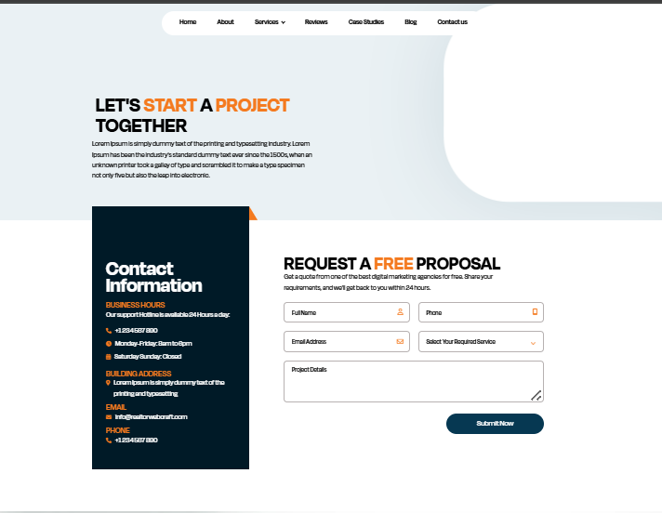

LET’S BUILD YOUR REAL ESTATE PLATFORM
Whether you need a custom real estate website, IDX integration, Android app development, or digital marketing for realtors, our team is ready to help you grow.
At Realtor Web Craft, we specialize in building powerful digital solutions designed specifically for real estate professionals. Let’s turn your ideas into a high-performing platform that drives leads and increases sales.

WHY CONTACT REALTOR WEB CRAFT?
✔ Real estate focused development team
✔ MLS and IDX integration specialists
✔ Custom website and app solutions
✔ Performance driven digital marketing
✔ Ongoing technical support
We understand the real estate market. That means faster execution, smarter features, and better results.

NEED IMMEDIATE ASSISTANCE?
Call us directly for urgent inquiries or project consultations.
Our team is ready to guide you through every step of your digital journey.

REQUEST A FREE PROPOSAL
Tell us about your project and we’ll prepare a tailored strategy for your real estate business.
We respond within 24 hours with:
• A clear project roadmap
• Feature recommendations
• Timeline estimate
• Transparent pricing
• Expert guidance
No obligations. Just clarity.

CONTACT INFORMATION

Business Hours
Monday – Friday: 9:00 AM – 6:00 PM
Saturday: 10:00 AM – 2:00 PM
Sunday: Closed

Phone
+1 23 445 6789

Email
info@realtorwebcraft.com

Office Address
Realtor Web Craft
Your City, State
United States

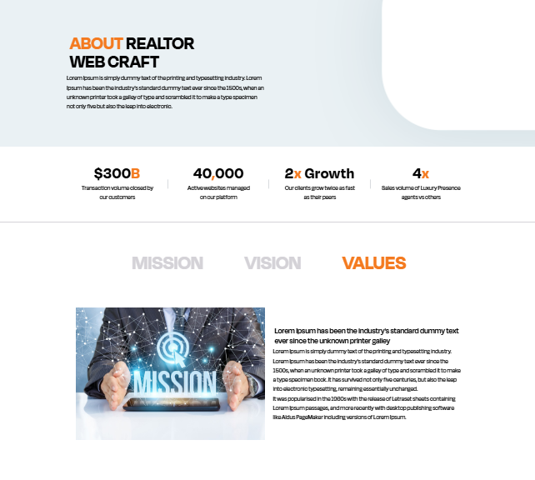

ABOUT REALTOR WEB CRAFT
Realtor Web Craft is a specialized real estate website development company dedicated to building high performance digital platforms for real estate professionals.
We understand that real estate is not just about listings. It is about visibility, trust, speed, and conversions. That is why we design and develop custom real estate websites, IDX integrated platforms, Android applications, and digital marketing systems that help agents, brokers, and agencies generate more qualified leads and close more deals.
Our team combines technical expertise with deep industry understanding to deliver scalable, secure, and conversion driven solutions tailored specifically for the real estate market.
We do not build generic websites.
We build real estate growth engines.

OUR MISSION
Our mission is to empower real estate professionals with cutting edge digital solutions that simplify property discovery, improve client engagement, and maximize lead generation.
We aim to provide custom real estate websites and technology platforms that help our clients stand out in a competitive market while delivering measurable business growth.

OUR VISION
Our vision is to become a leading global real estate website development company recognized for innovation, performance, and client success.
We strive to redefine how real estate businesses operate online by integrating advanced technology, intelligent automation, and data driven strategies into every platform we build.
We envision a future where every real estate professional has access to powerful digital tools that drive consistent growth and long term success.

OUR VALUES

Industry Focused Expertise
We specialize in real estate. Every solution we create is designed with real estate workflows and client behavior in mind.

Innovation & Performance
We build modern, scalable, and fast platforms that perform reliably and adapt to your business growth.

Transparency & Integrity
Clear communication, honest pricing, and measurable results are at the core of our partnerships.

Client Success First
Your growth is our priority. We measure our success by the leads, conversions, and revenue you generate.

Long Term Partnership
We believe in building relationships, not just projects. From development to maintenance, we support you every step of the way.

